**Work Completed by 05/03/2020**

* **Entire front-end is ready**
* **Database Design is ready**
* **Linking of few WebPages is done**
* **Dataset for prediction is ready**
* **PPT is done.**



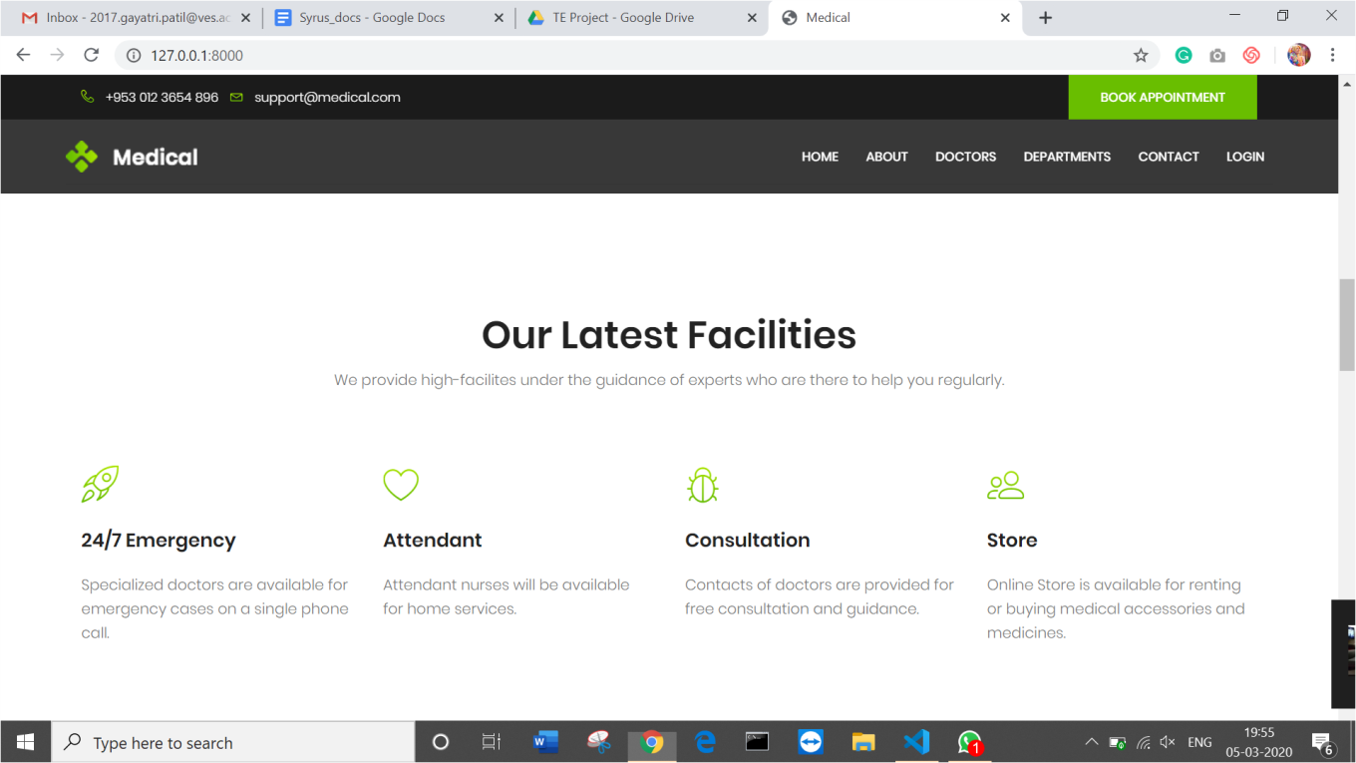



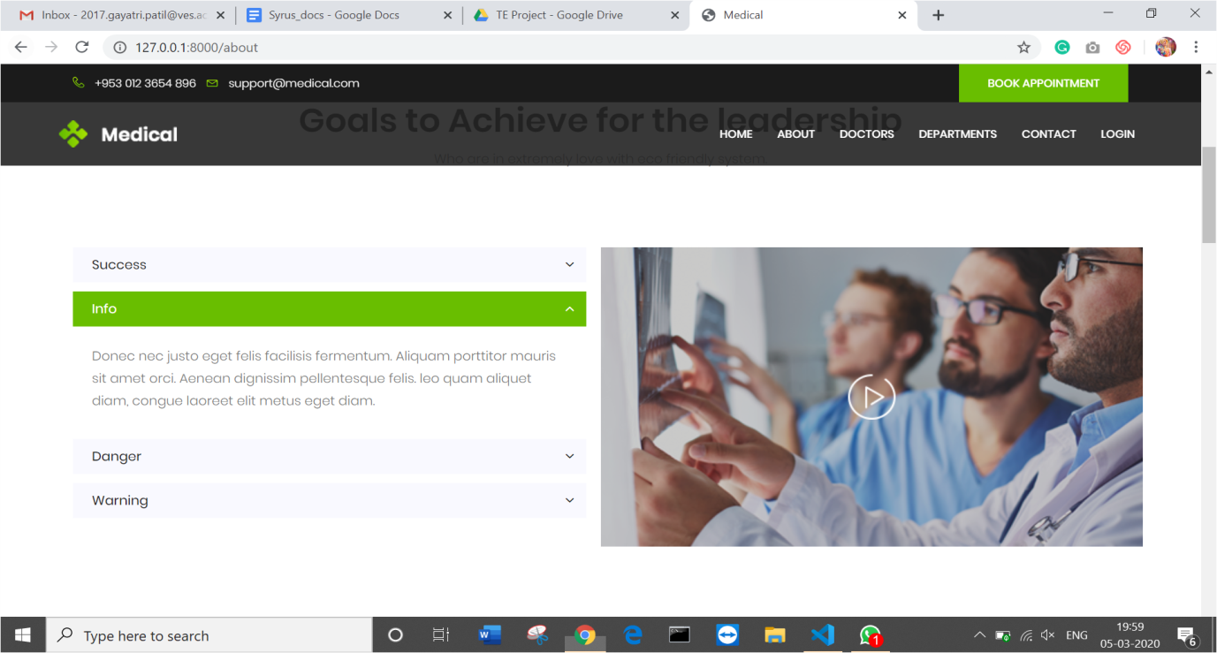

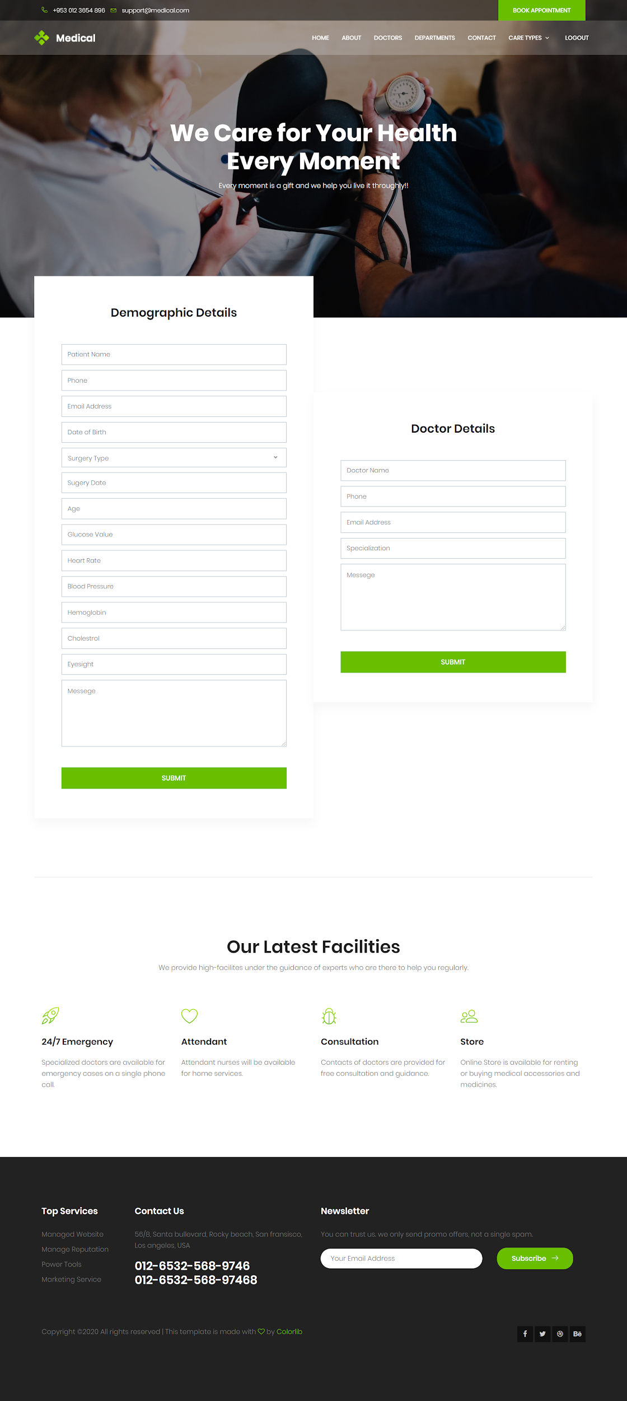

**Work that will be completed by 06/03/2020**

* **back-end and frontend connectivity**
* **Modeling**
* **Testing**
* **Deployment of website**